INFO 7250 Project: Million Song Dataset

*Achal Sancheti, Saurabh Choudhary, Sumit Deshmukh*

*08 August 2016*

1. **Introduction**

The Million Songs Dataset is a collection of 28 datasets containing audio features and metadata for a million contemporary popular music tracks. The core of the dataset is the feature analysis and metadata for one million songs, provided by [The Echo Nest](http://the.echonest.com/). *The dataset does not include any audio, only the derived features*. Sample audio can be fetched from services like [7digital](http://www.7digital.com/).

* 1. **About Dataset**

The MSD contains audio features and metadata for a million contemporary popular music tracks. Some of the interesting facts about the dataset:

* 280 GB of data
* 1, 000, 000 songs/files
* 44, 745 unique artists
* 7, 643 unique terms (Echo Nest tags)
* 2, 321 unique MusicBrainz tags
* 43, 943 artists with at least one term
* 2, 201, 916 asymmetric similarity relationships
* 515, 576 dated tracks starting from 1922

The data is stored in HDF5 format to efficiently handle the heterogeneous types of information such as audio features in variable array lengths, names as strings, longitude/latitude, similar artists, etc.

We used another Dataset that had information about how these songs have been listened by 1 Million users. [The Echo Nest Taste Profile Subset](http://labrosa.ee.columbia.edu/millionsong/tasteprofile) has a 3 columns namely

* User ID: User ID of 1 Million users of Echonest
* Song ID: Song ID in the MSD dataset
* Num\_Played: Number of times song is played

These are the questions for which we are presenting answers in this report.

* + 1. **Using MapReduce**

1. Number of songs released in each year.
2. Number of artists debuted per year.
3. Number of songs sung by an artist.
4. Play count for each song.
5. Number of artists per MusicBrainz tag.
6. Geographic distribution of each artist using google API.
7. Most dense, hottest, loudest and longest song in the dataset.
8. Analyzing the increase and decrease of song duration each year.
9. Analyzing the increase and decrease of beats for the songs over the period.
   * 1. **Using Pig**
10. Top 50 most viewed songs.
11. Top 10 years with highest number of song release.
12. 3. Top 10 years with highest number of artist debut
13. 4. List of highest beats song before 1980.
    * 1. **Using Neo4j**
14. Displaying the relationship between users and songs using graph database (Neo4j).
15. Web demo to get the details of a particular song, that is connected with Neo4j graph database.
    * 1. **Using Microsoft Azure (Machine Learning)**
16. Predicting the possible number of audience for the upcoming song.
17. Predicting the possible number of views for the upcoming song.

|  |  |  |
| --- | --- | --- |
| **Field Name** | **Type** | **Description** |
| Analysis\_sample\_rate | float | sample rate of the audio used |
| Artist\_7dID | String | ID from 7digital.com |
| Artist\_familiarity | float | algorithmic estimation |
| Artist\_hotness | float | algorithmic estimation |
| Artist\_ID | String | Echo Nest ID |
| Artist\_latitude | float | latitude |
| Artist\_location | String | location name |
| Artist\_longitude | float | longitude |
| Artist\_name | String | artist name |
| Audio\_MD5 | String | audio hash code |
| Number\_of\_beats[[1]](#footnote-2) | Integer | Total beats in a song. |
| Danceability | Float | algorithmic estimation |
| Duration | Float | in seconds |
| End\_of\_fade\_in | Float | seconds at the beginning of the song |
| Energy | Float | energy from listener point of view |
| loudness | Float | overall loudness in dB |
| release | String | album name |
| release\_7dID | String | ID from 7digital.com or |
| Hotness | Float | algorithmic estimation |
| SongID | String | Echo Nest song ID |
| Start\_of\_fade\_out | Float | time in sec |
| Tempo | Float | estimated tempo in BPM |
| Title | String | song title |
| TrackID | String | Echo Nest track ID |
| Track\_7dID | String | ID from 7digital.com |
| Year | Integer | song release year from MusicBrainz |
| Artist\_mbID | String | ID from musicbrainz.org |
| Artist\_mbTags | String [] | tags from musicbrainz.org |
| Artist\_mbCount | Float [] | tag counts for musicbrainz tags |
| Artist\_PlaymeID | String | ID from playme.com |
| Artist\_Terms | String [] | Echo Nest tags |
| Artist\_TermFrequency | Float [] | Echo Nest tags frequency |
| Artist\_TermWeight | Float [] | Echo Nest tags weight |
| Similar\_Artists | String [] | Echo Nest artist IDs (sim. algo. unpublished) |
| user\_count | Integer | Number of unique users played the song |
| Play\_count | Integer | Total number of times a song is played |

* 1. **Description of fields from MSD**

Table : Description of fields in the MSD Dataset

1. **Dataset Preparation**

The original dataset is in HDF5 format, which is not native to Hadoop. HDF5 is a file format for storing and managing data. It supports an unlimited variety of datatypes, and is designed for flexible and efficient I/O and for high volume and complex data. HDF5 does not enforce the use of UTF-8, so applications may be expecting ASCII in most places. Therefore, using Java program we have preprocessed this data from HDF5 format to CSV format.

Below screen-shot shows a code snippet used for data conversion using multiple getters for each field:

The method in below code makes sure that each file in HDF5 format is read for every sub-directory and extracted all the song information: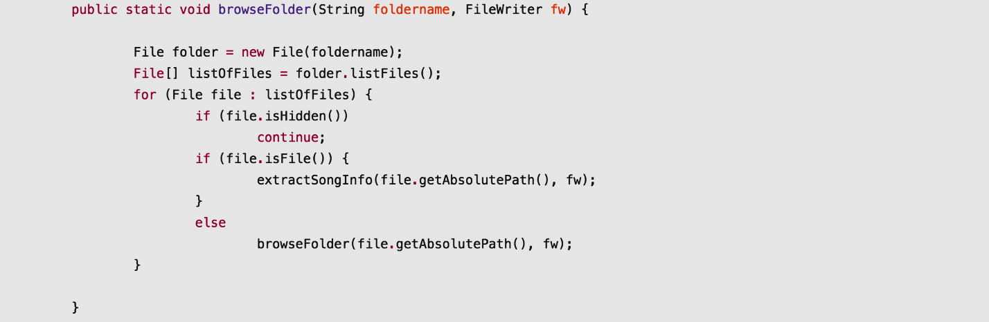

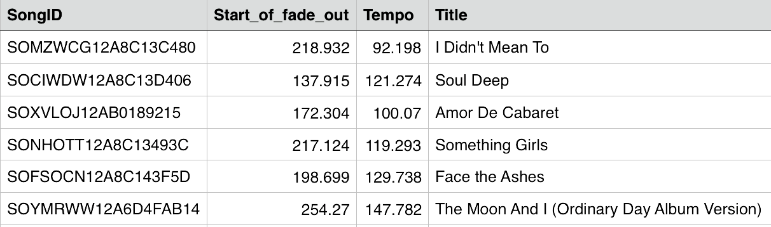Using HDF5 getters we extracted 36 fields and the final output CSV file generated contains data as below

Table 2: Sample Columns of the Dataset (Song)

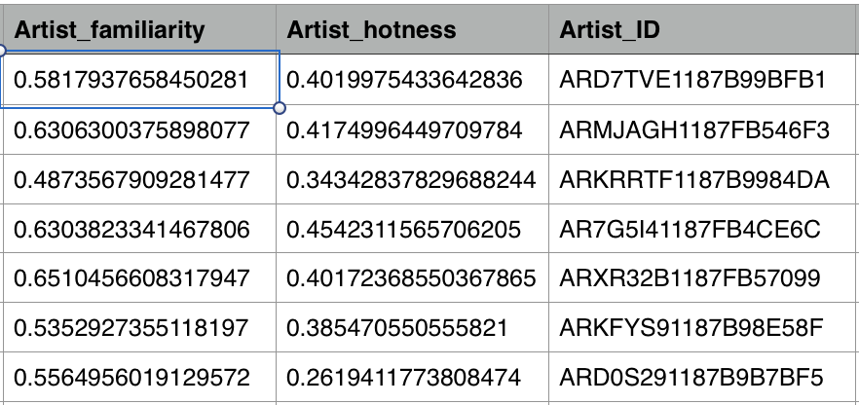

Table 3: Sample Columns of the Dataset (Artist)

1. **Data Sanitization**

When we converted from HDF5 format to simple TSV file we faced issues of junk data cropping up in our Dataset. We cleaned this dataset by converting numeric values to their respective datatypes.

|  |  |
| --- | --- |
| Type | Replaced Values |
| Integer | 0 |
| Float | 0.0 |
| String | NA |
| Array | [] |

Table 4: Data cleaning and Filling Missing values

1. **Map/Reduce Jobs**
   1. **Number of songs released in each year**

This M/R (Map/Reduce) job simply calculates the number of songs released per year providing the overview of growth in song release through the years.

**Map**: Emit Year as key and ‘1’ value.

**Reduce**: Collect the year as key and sum of number of Song Ids as final value of number of songs.

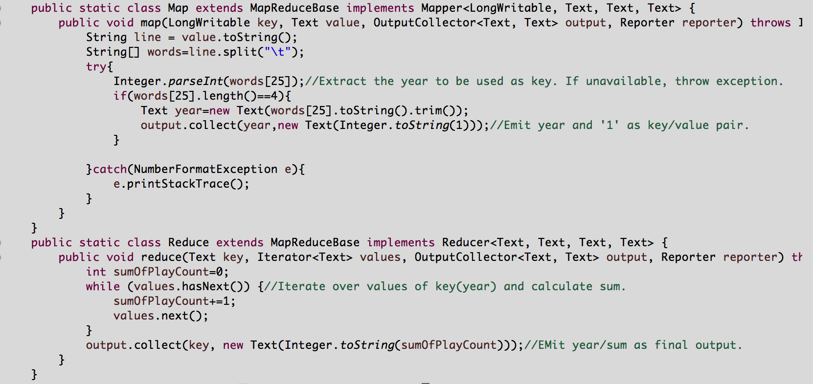

Graph for number of songs released per year is below:

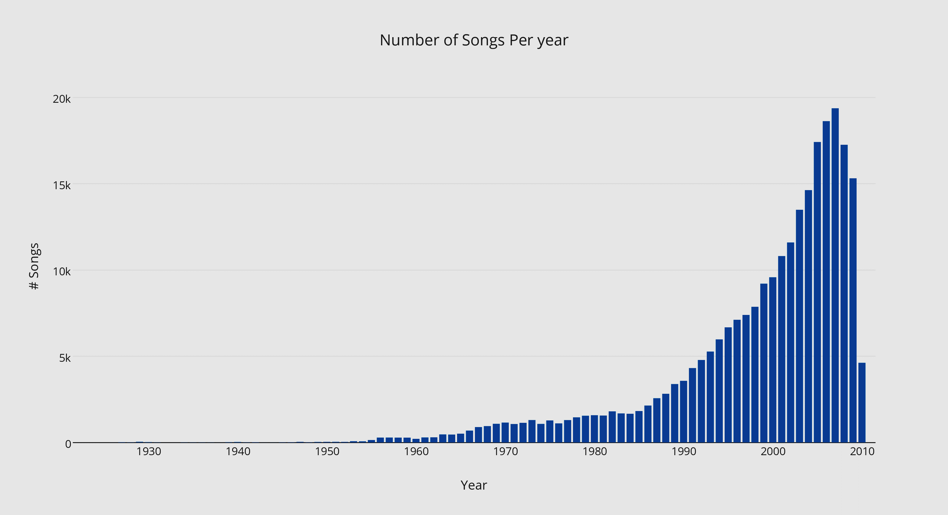

Figure 1: Number of Songs released per Year

* 1. **Number of artists debuted per year**

Calculates the possible number of artist that made a debut in a year. To extract this information, chained m/r job is used.

**M/R 1**: Emit artistId/year as key value pair. The output is artistId/year[] which is used as input for M/R 2.

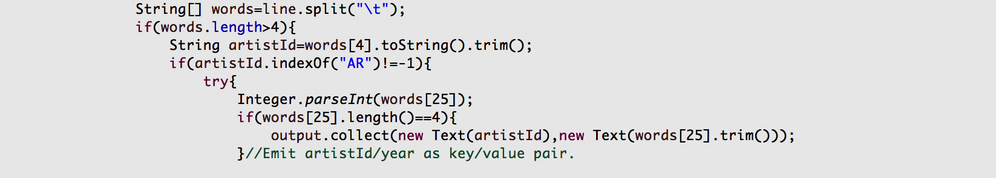

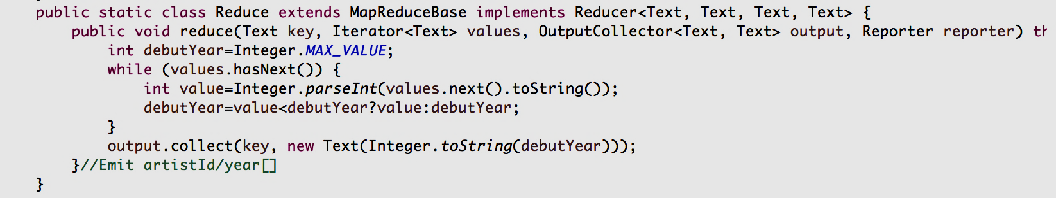

**M/R 2**: From the artistId/year [], the mapper extract the smallest\_year. Then, the artistId/ smallest\_year is emitted and the reducer sums up the number of all years for key artistId. The sum is finally the number of artists debuted per year.

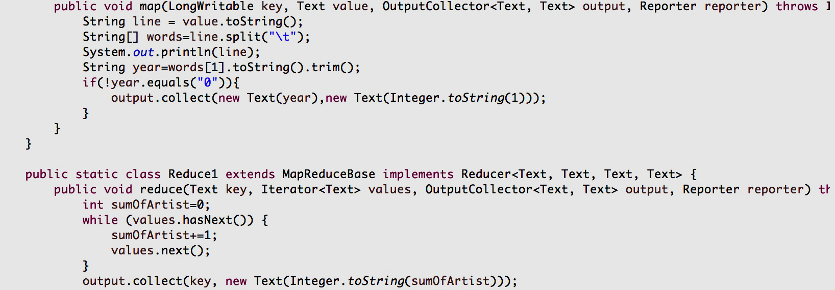

Graph for total number of artists per year is below:

[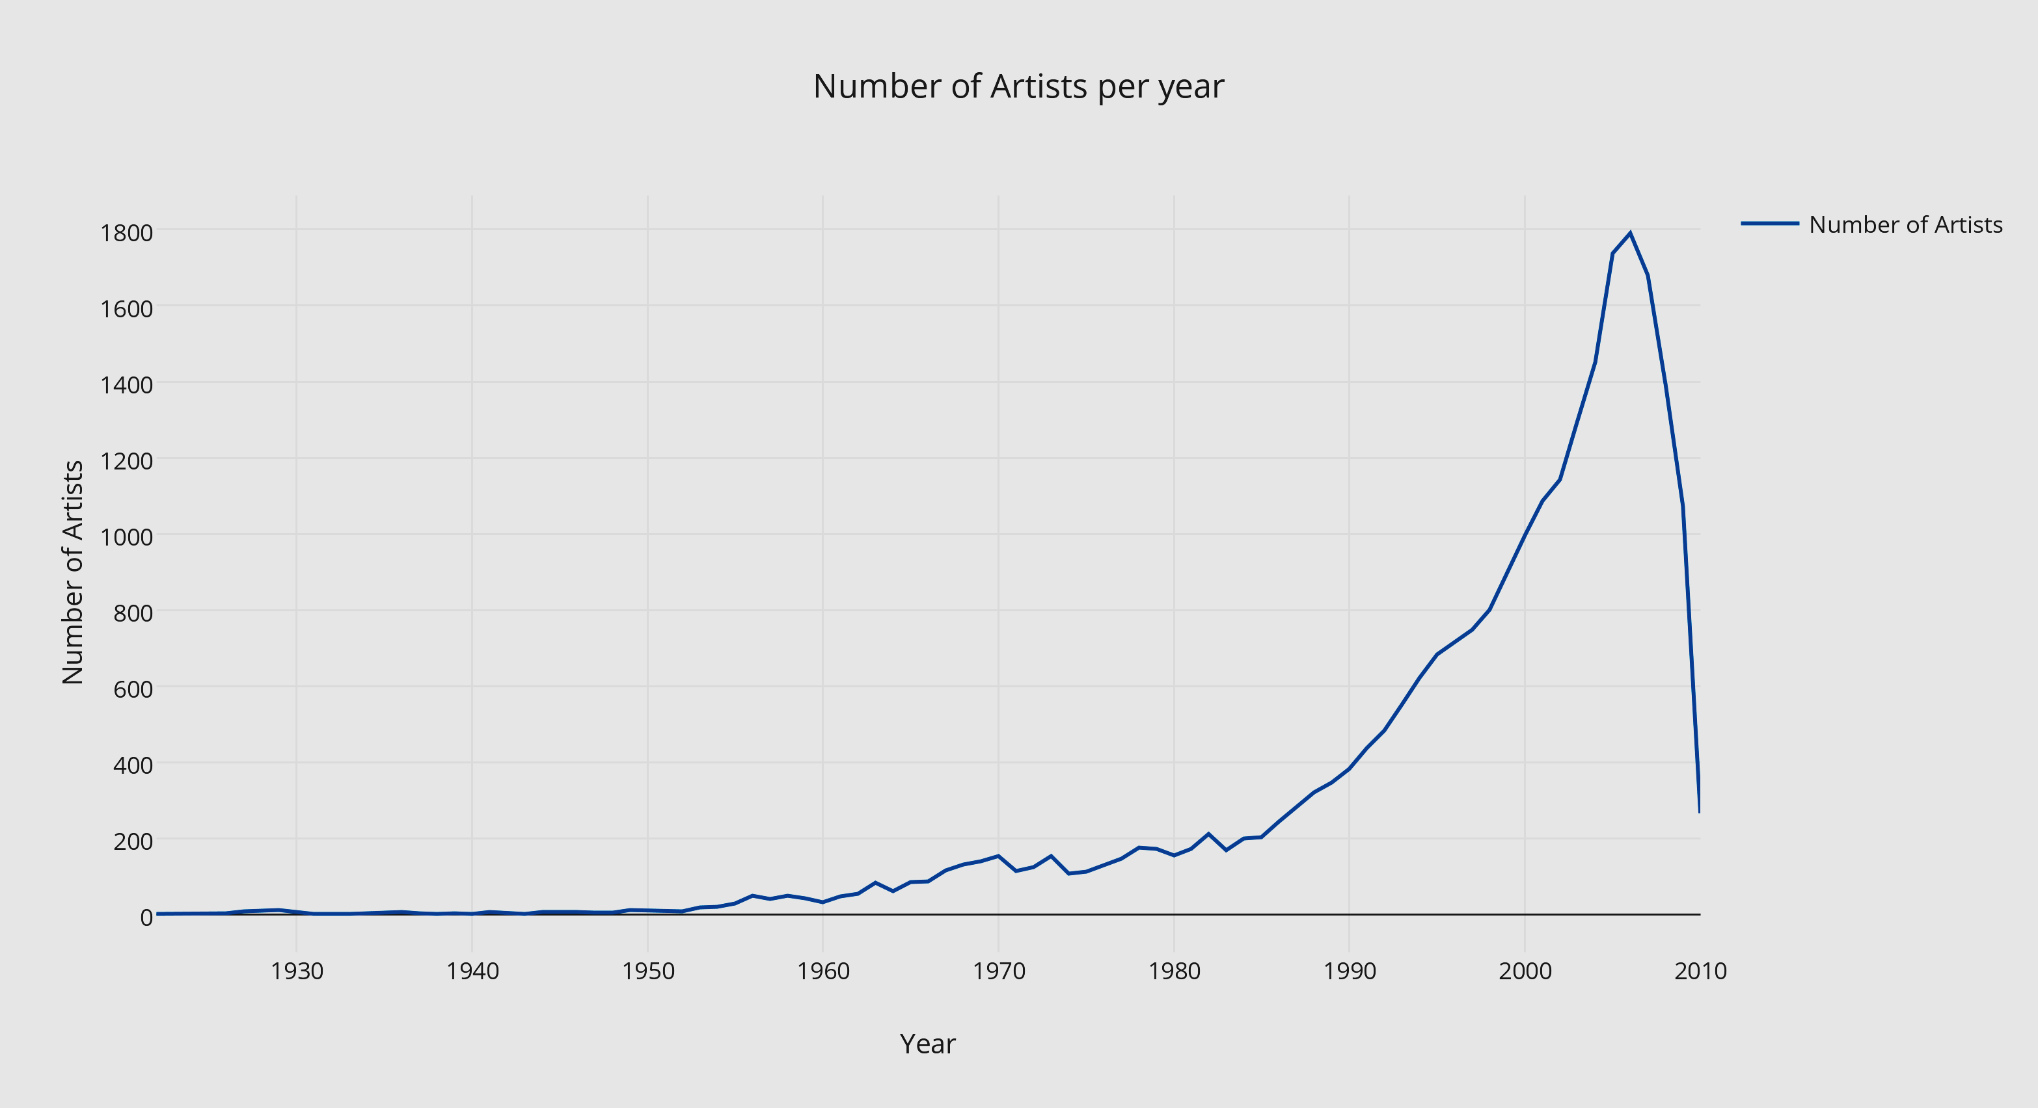](https://plot.ly/~saurabhc31/14/)

Figure 2: Number of Artist Debuted per Year

* 1. **Number of songs sung by an artist**

Calculates the total songs sung by an artist from millions of songs. The artistId is emitted as key and an identity reducer simply sums up the occurrence of same key which yields the number of song for a specific artistId.

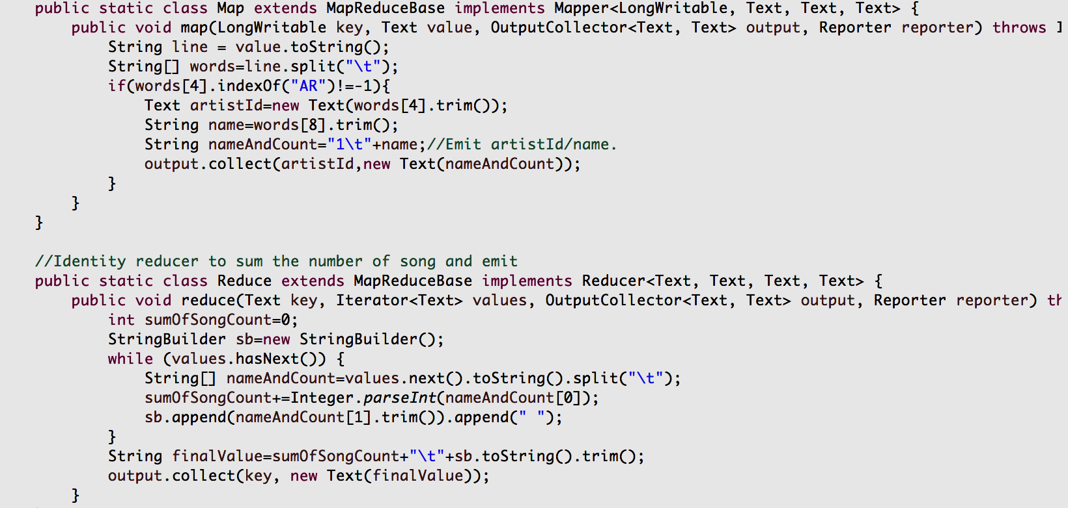

* 1. **Play count for each song**

Calculates the total number of times a specific song is played by unique users from a subset. The subset is Taste Profile Dataset which contains real user - play counts and songId, matched to the MSD.

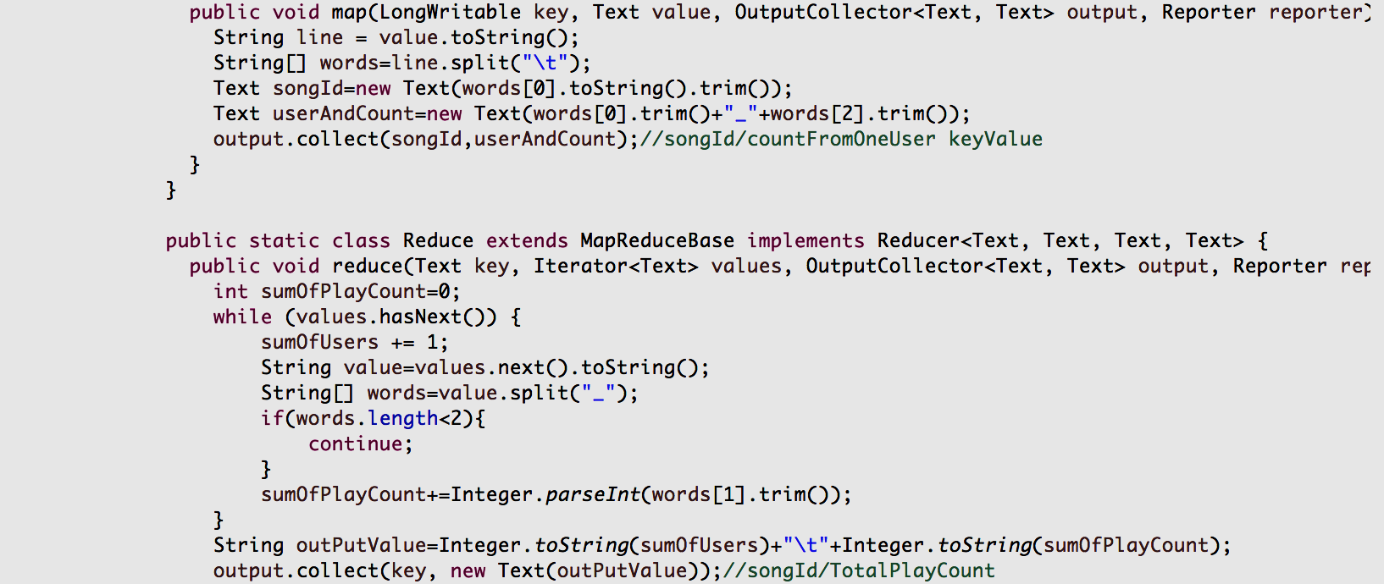

* 1. **Artists per MusicBrainz Tags**

This M/R job identifies the distribution of artist across different genre depending upon the tags given to artists by users on MusicBrainz.com. This also requirs chained M/R jobs.

**M/R 1**: Mapper emits genre\_artistId/1 as key value pair and reducer generates the output file with genre\_artistId/totalcount. This is used as input for next M/R job.

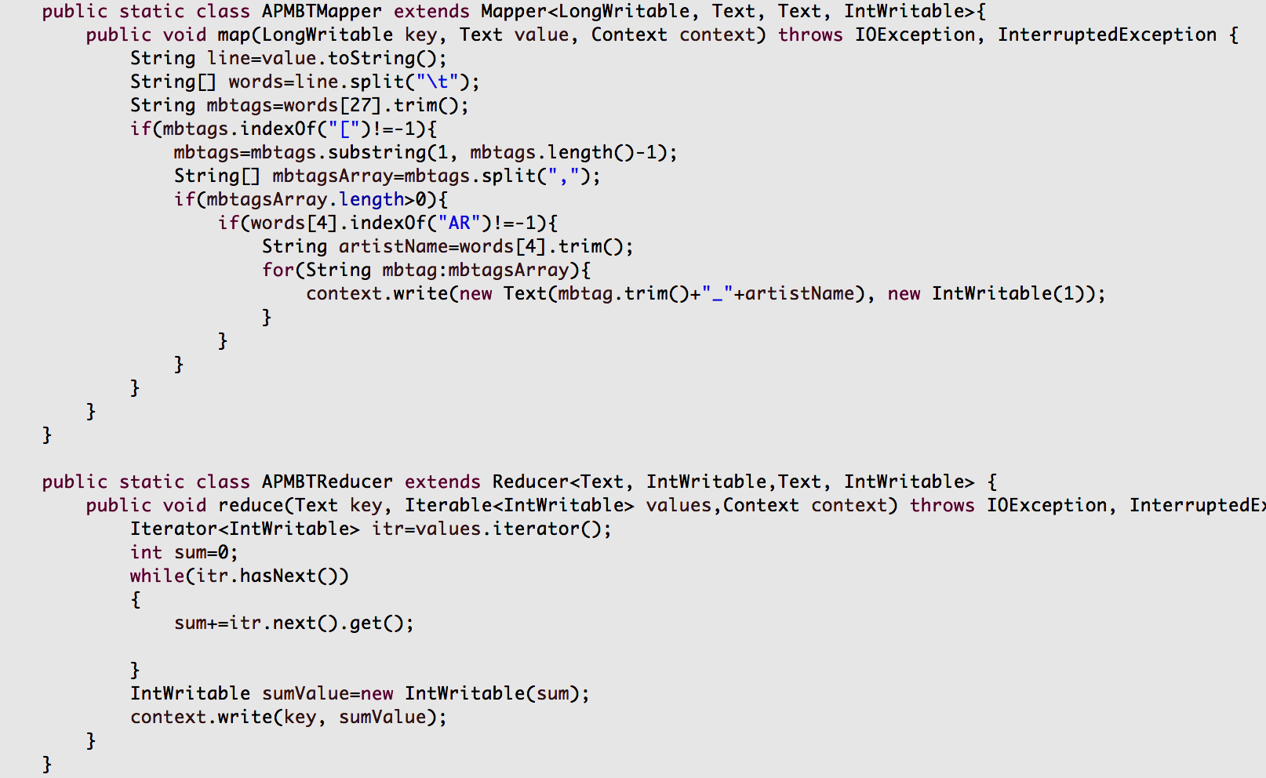

**M/R 2**: The key genre\_artistId is split into genre/artistId in mapper and reducer simply sums up the number of artists for a given genre.

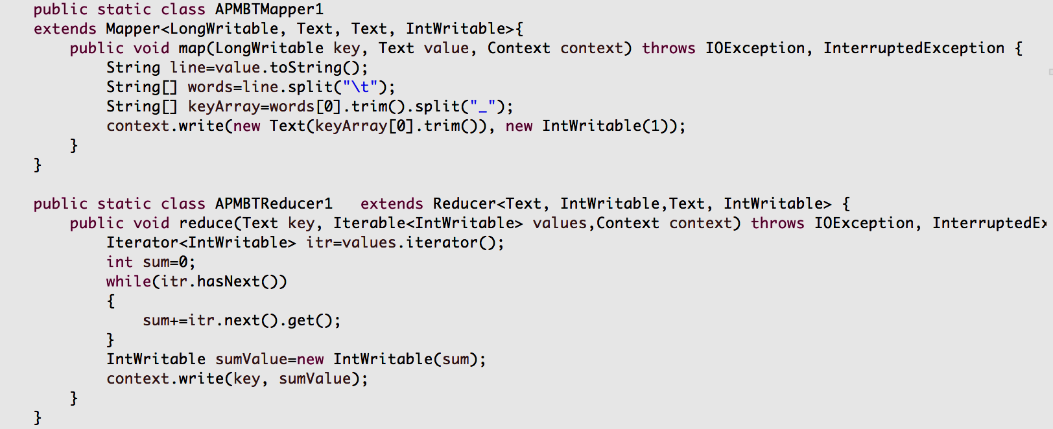

Graph displaying the number of artists for each MusicBrainz Tag:

[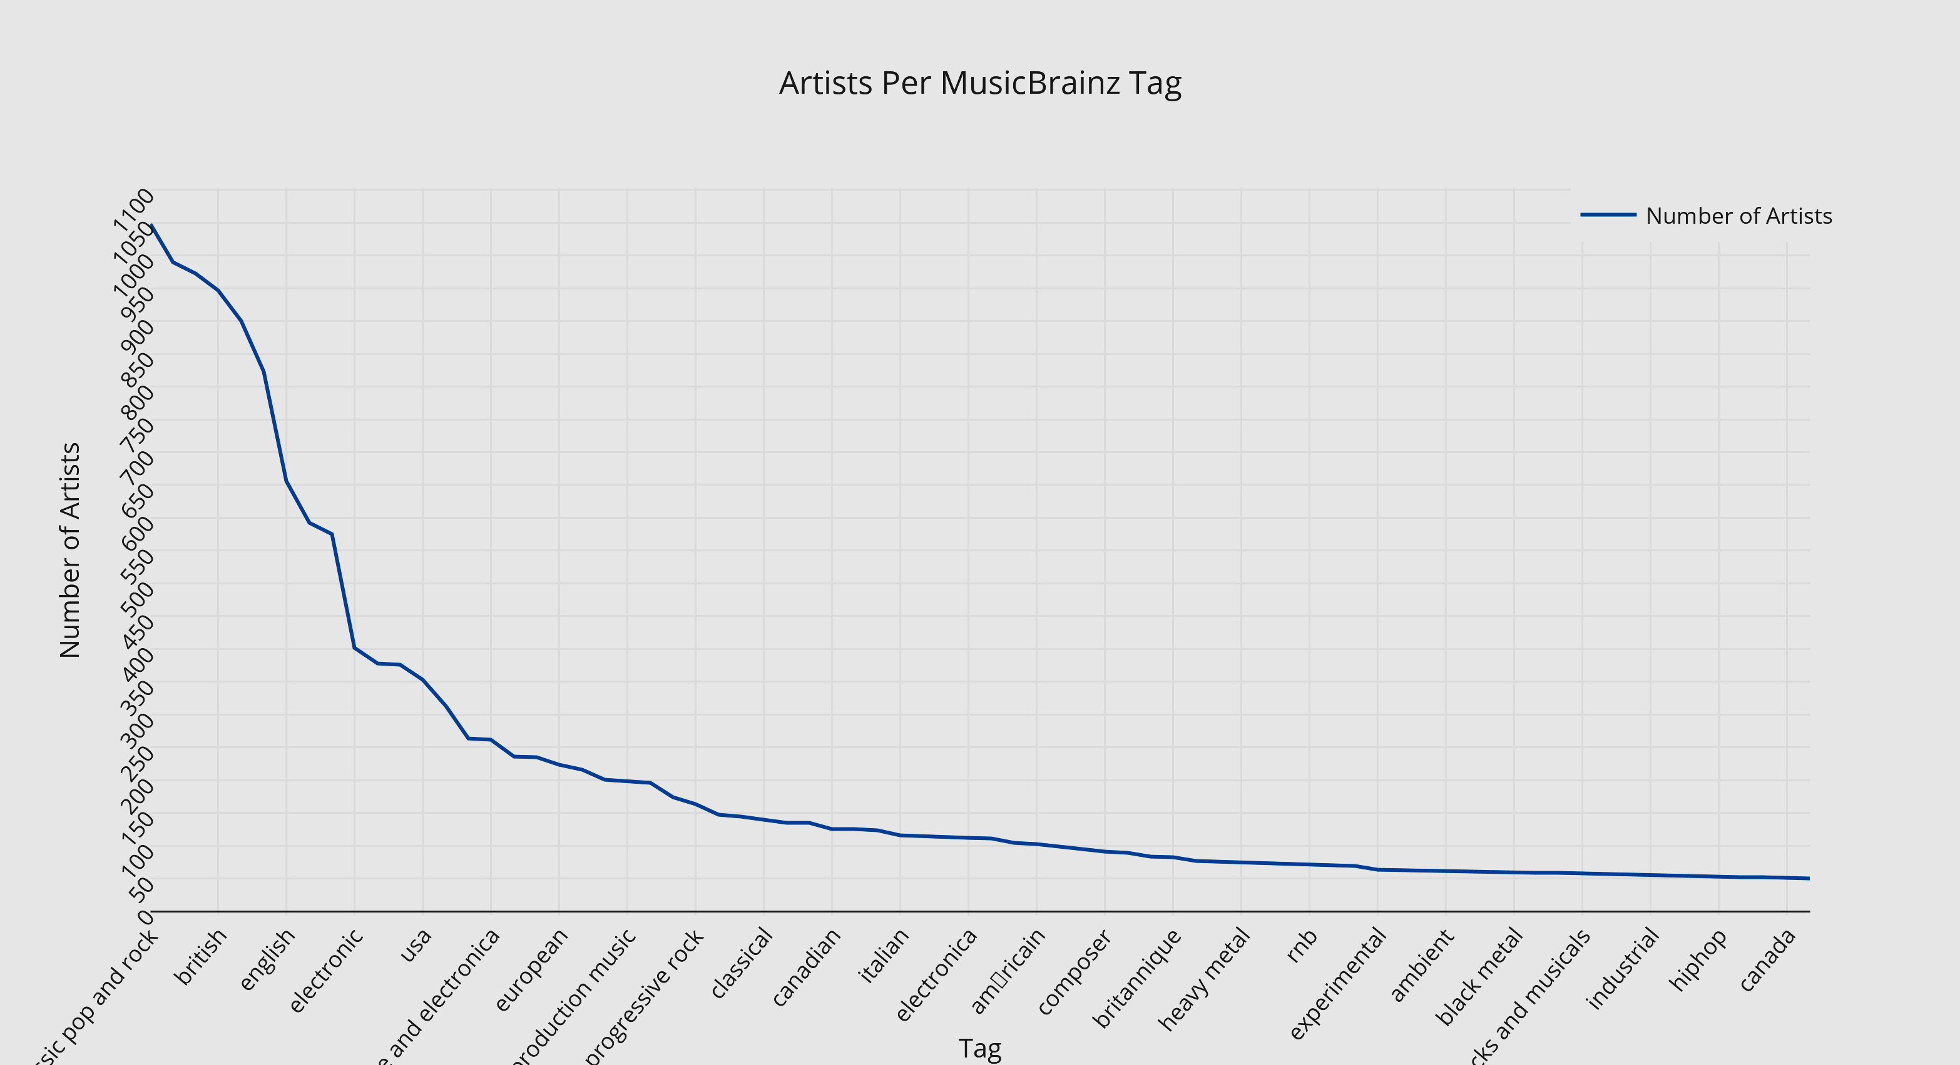](https://plot.ly/~saurabhc31/27/artists-per-musicbrainz-tag/)

Figure 3: Artist per genre according to MusicBrainz

* 1. **Geographic distribution of each artist using google API**

A simple M/R to just emit the longitude and latitude for a given artist. This data is then utilized in Google Maps API and a plot of geographic distribution of artists is obtained. It simplifies identification of geographic hotspots of artists.



Figure 4: Geographical Distribution of all artists in the MSD

* 1. **Most dense, hottest, loudest and longest song in the dataset**

All the information is derived from similar M/R where just the fields are replaced to generate the individual result. Most dense song is the one with highest Beats/second value.

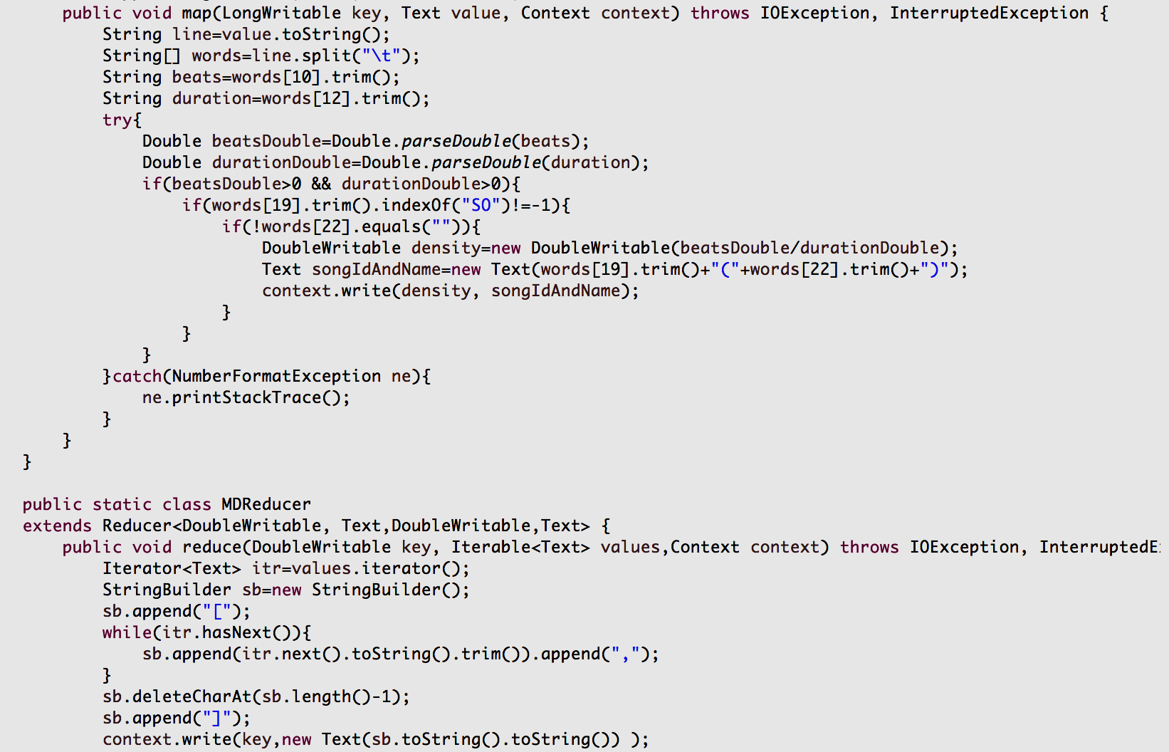

* 1. **Analyzing the increase and decrease of song duration each year**

This M/R generates the average duration of songs for a given year.

**Mapper**: Emits the year/duration as key value pair.

**Reducer**: Calculations the total of list of duration for a given year and divides by the number of elements in the list to generate the average.

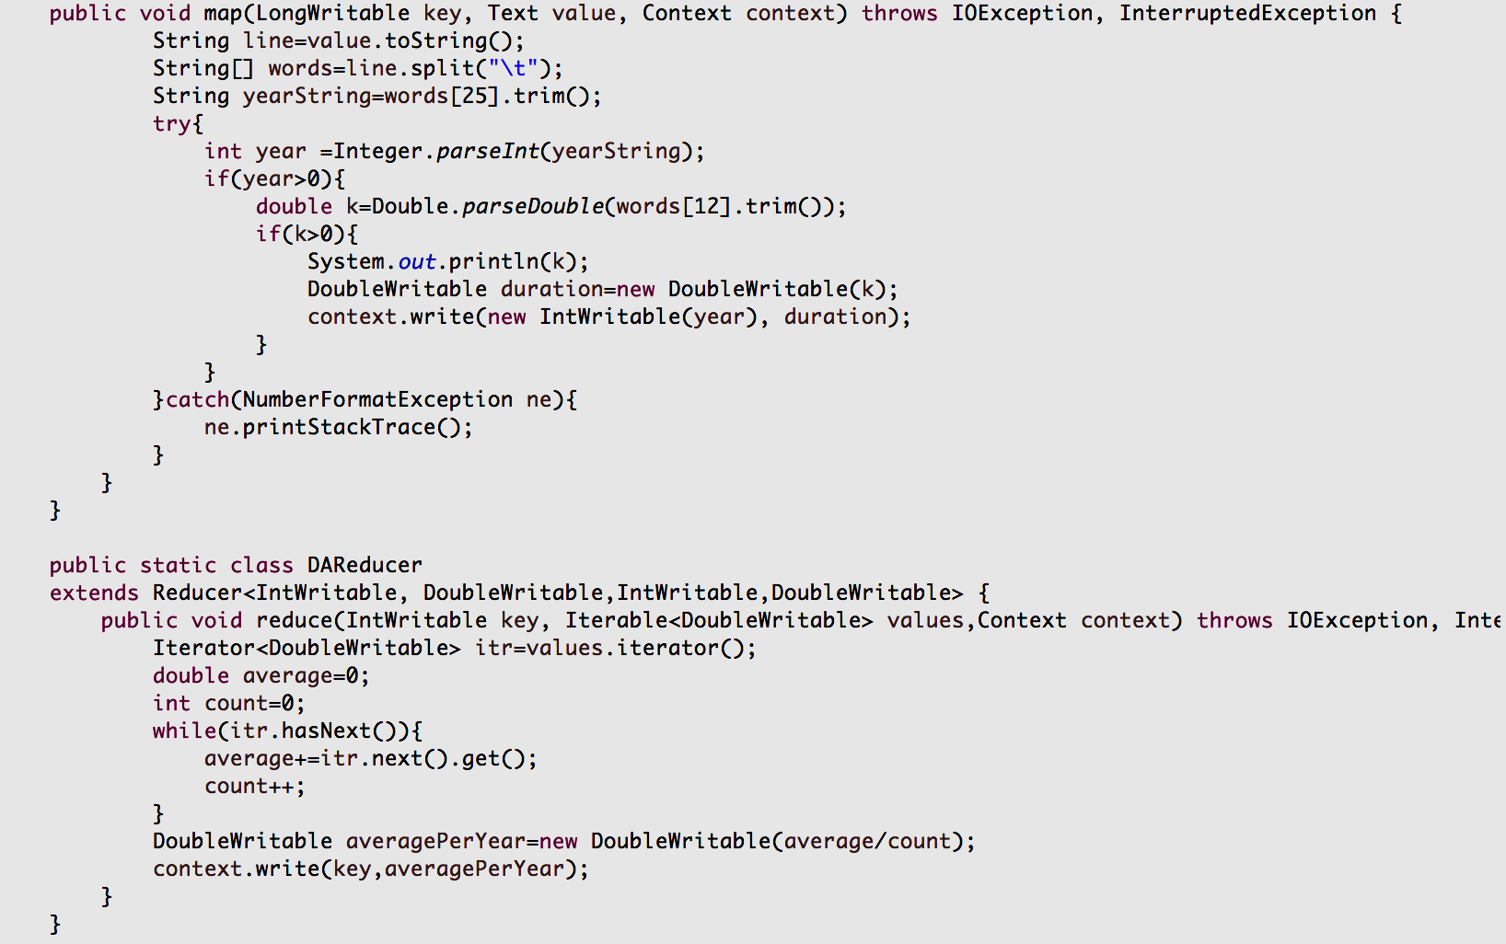This helps in understanding the trend of increase/decrease in duration through a graph.

[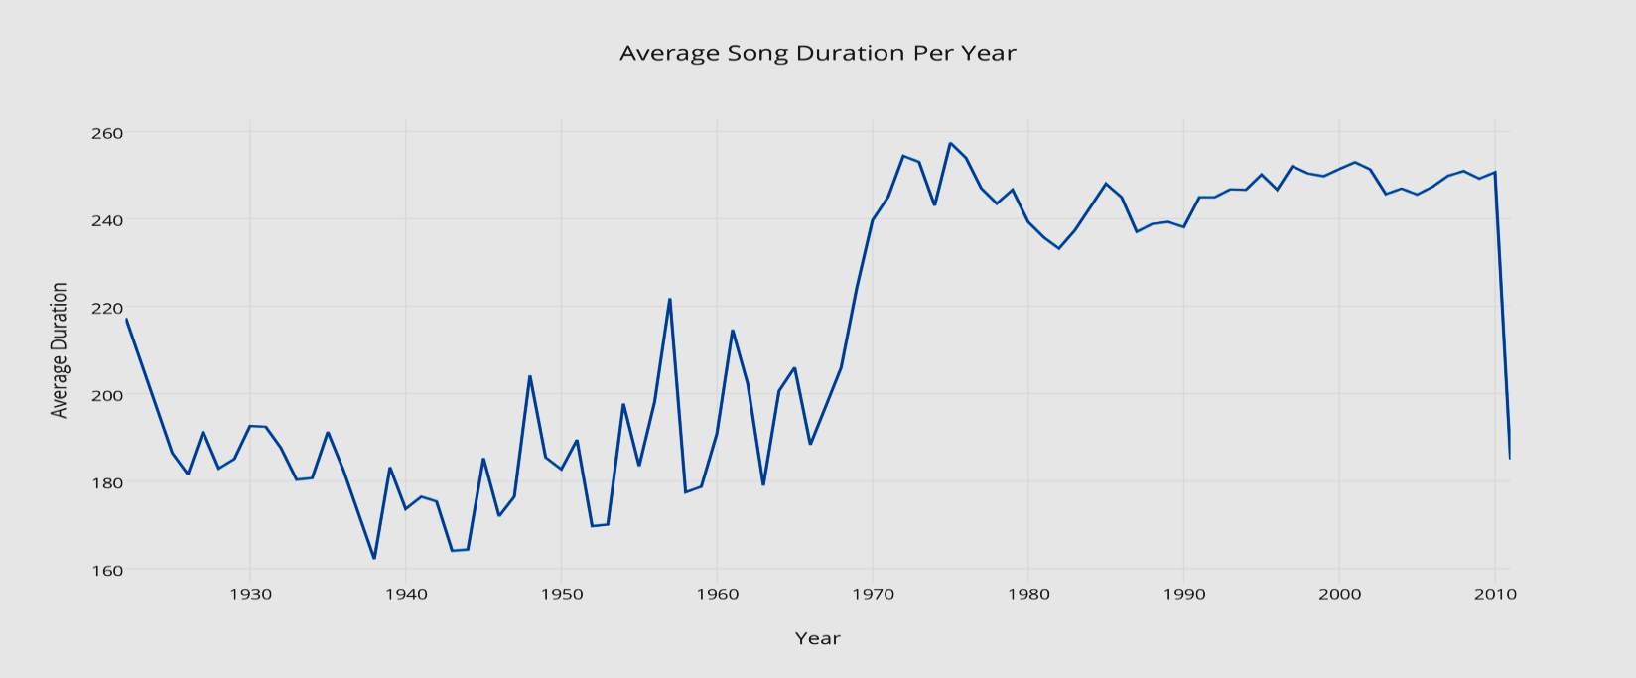](https://plot.ly/~saurabhc31/20/average-song-duration-per-year/)

Figure 5: Duration of songs (in seconds) in the MSD

* 1. **Analyzing the increase and decrease of beats for the songs over the period**

Similar to average duration per year, this M/R is utilized to understand the trend of beats through years.

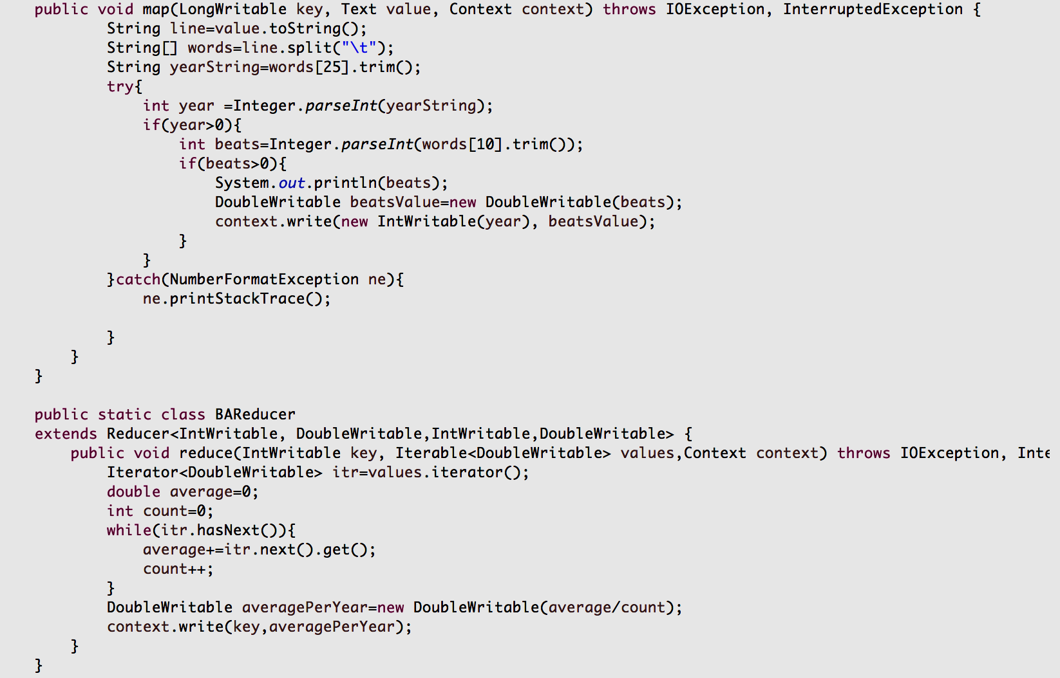

Graph displaying the average beat of a song in each year:

[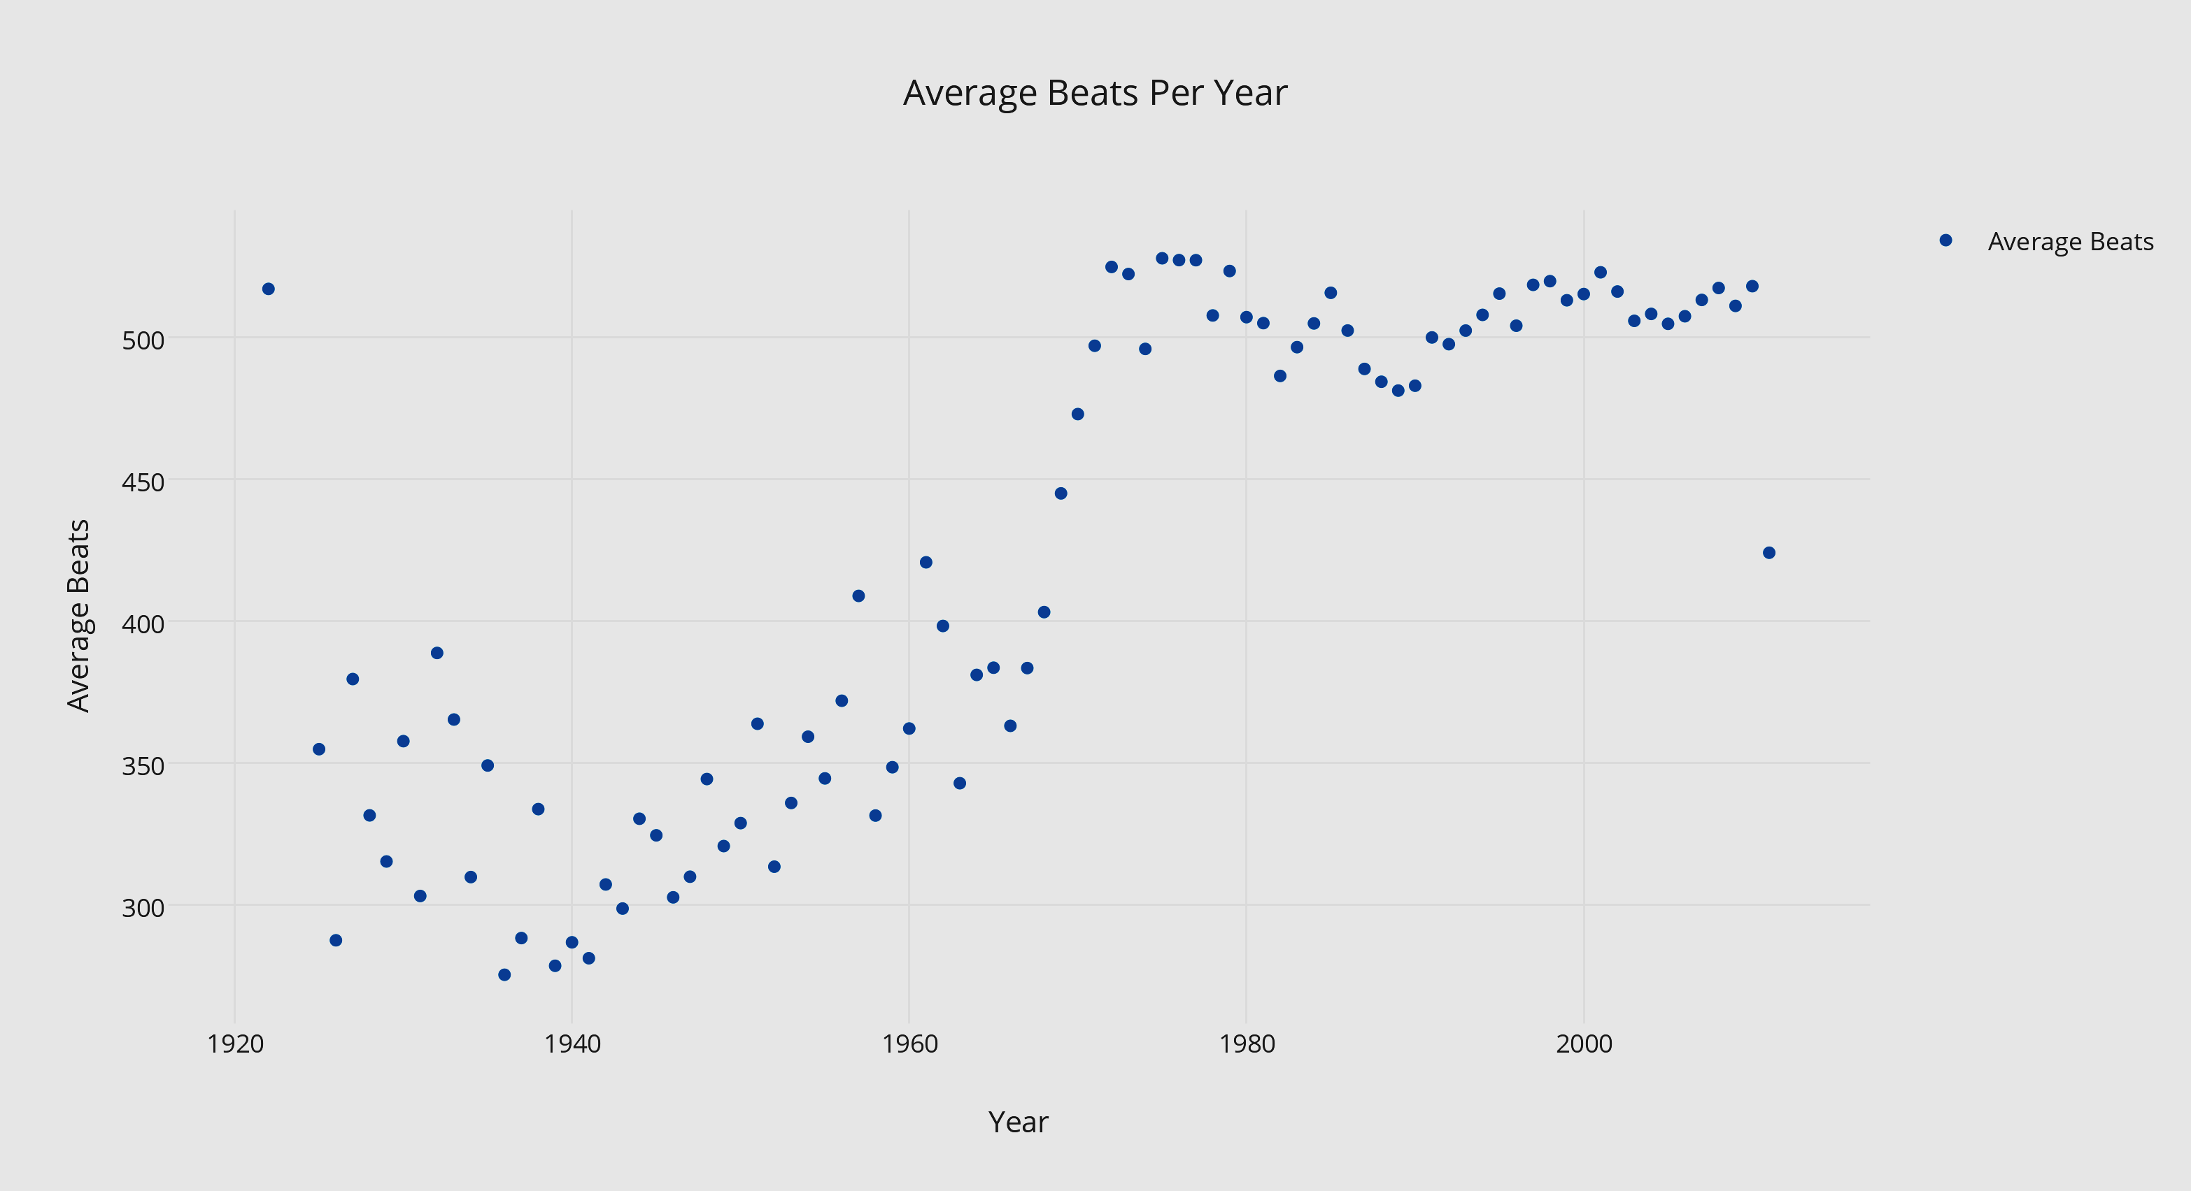](https://plot.ly/~saurabhc31/23/average-beats-per-year/)

Figure 6: Average Beats per songs per Year in the MSD

* 1. **Running the resource intensive Tasks in AWS EMR**

With Amazon EMR ([Amazon EMR](http://aws.amazon.com/emr)) you can analyze and process vast amounts of data. It does this by distributing the computational work across a cluster of virtual servers running in the Amazon cloud. The cluster is managed using an open-source framework [Hadoop](http://hadoop.apache.org/).

* + 1. **Overview of the Tasks**

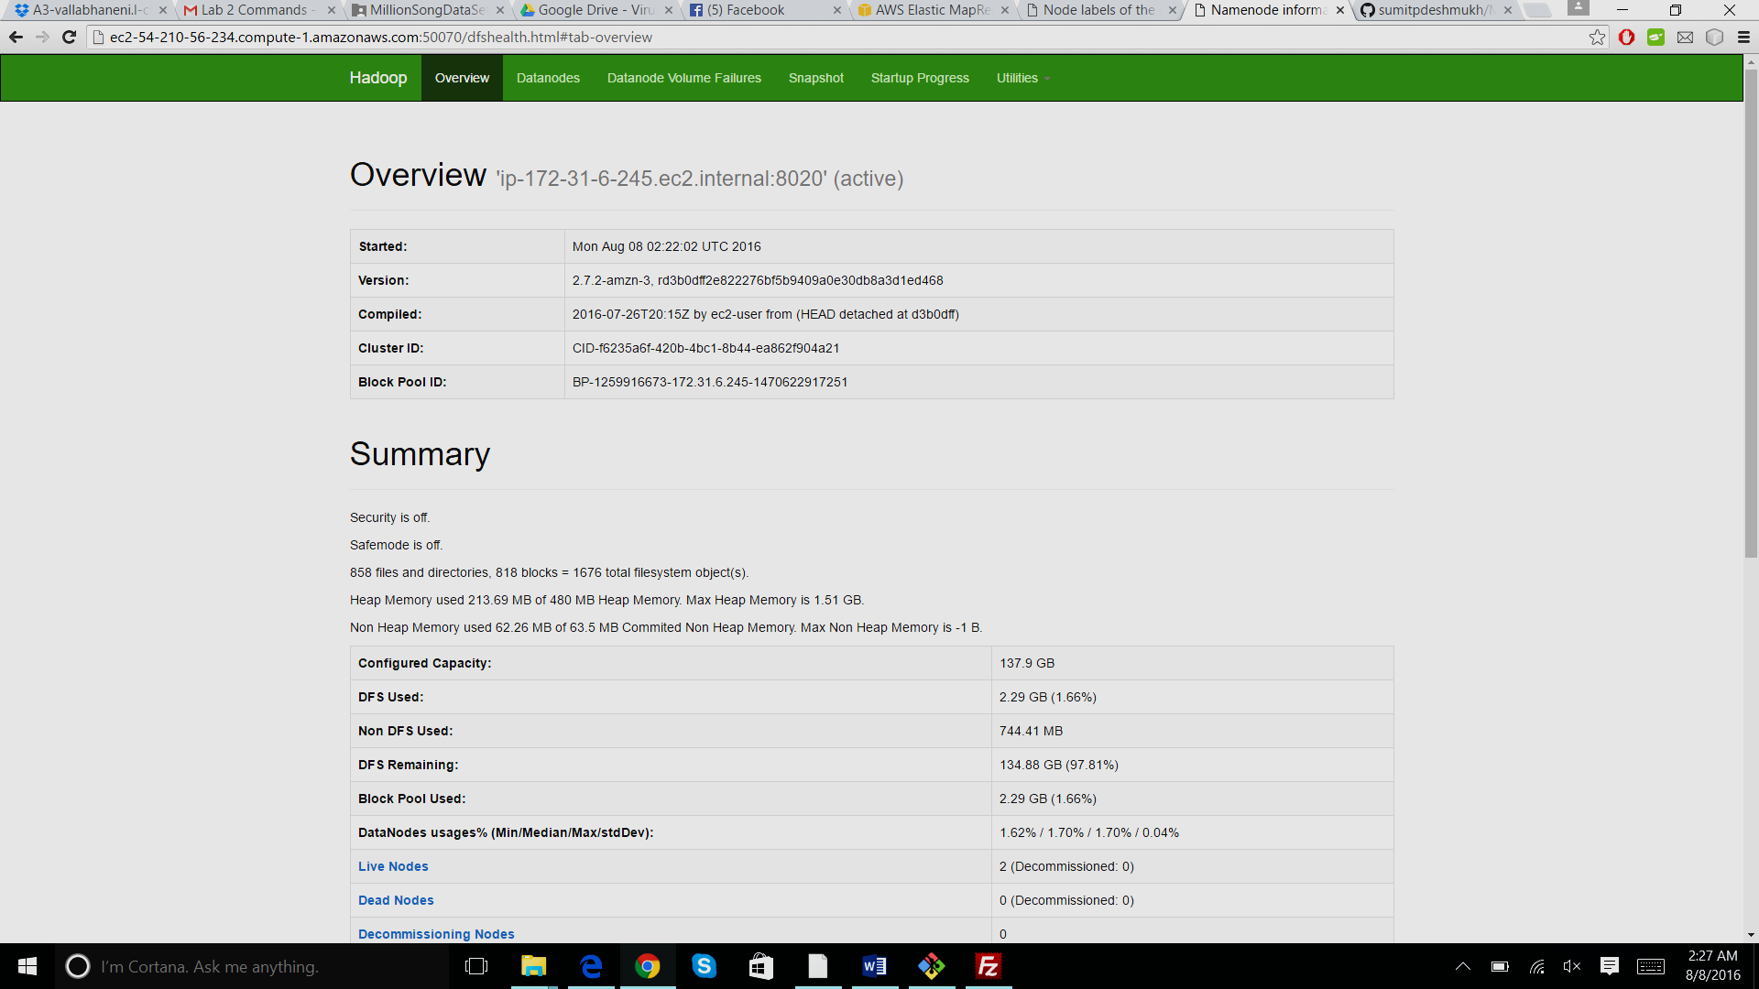

Figure 7: Summary of the MR job after completion

* + 1. **Datanode Information**

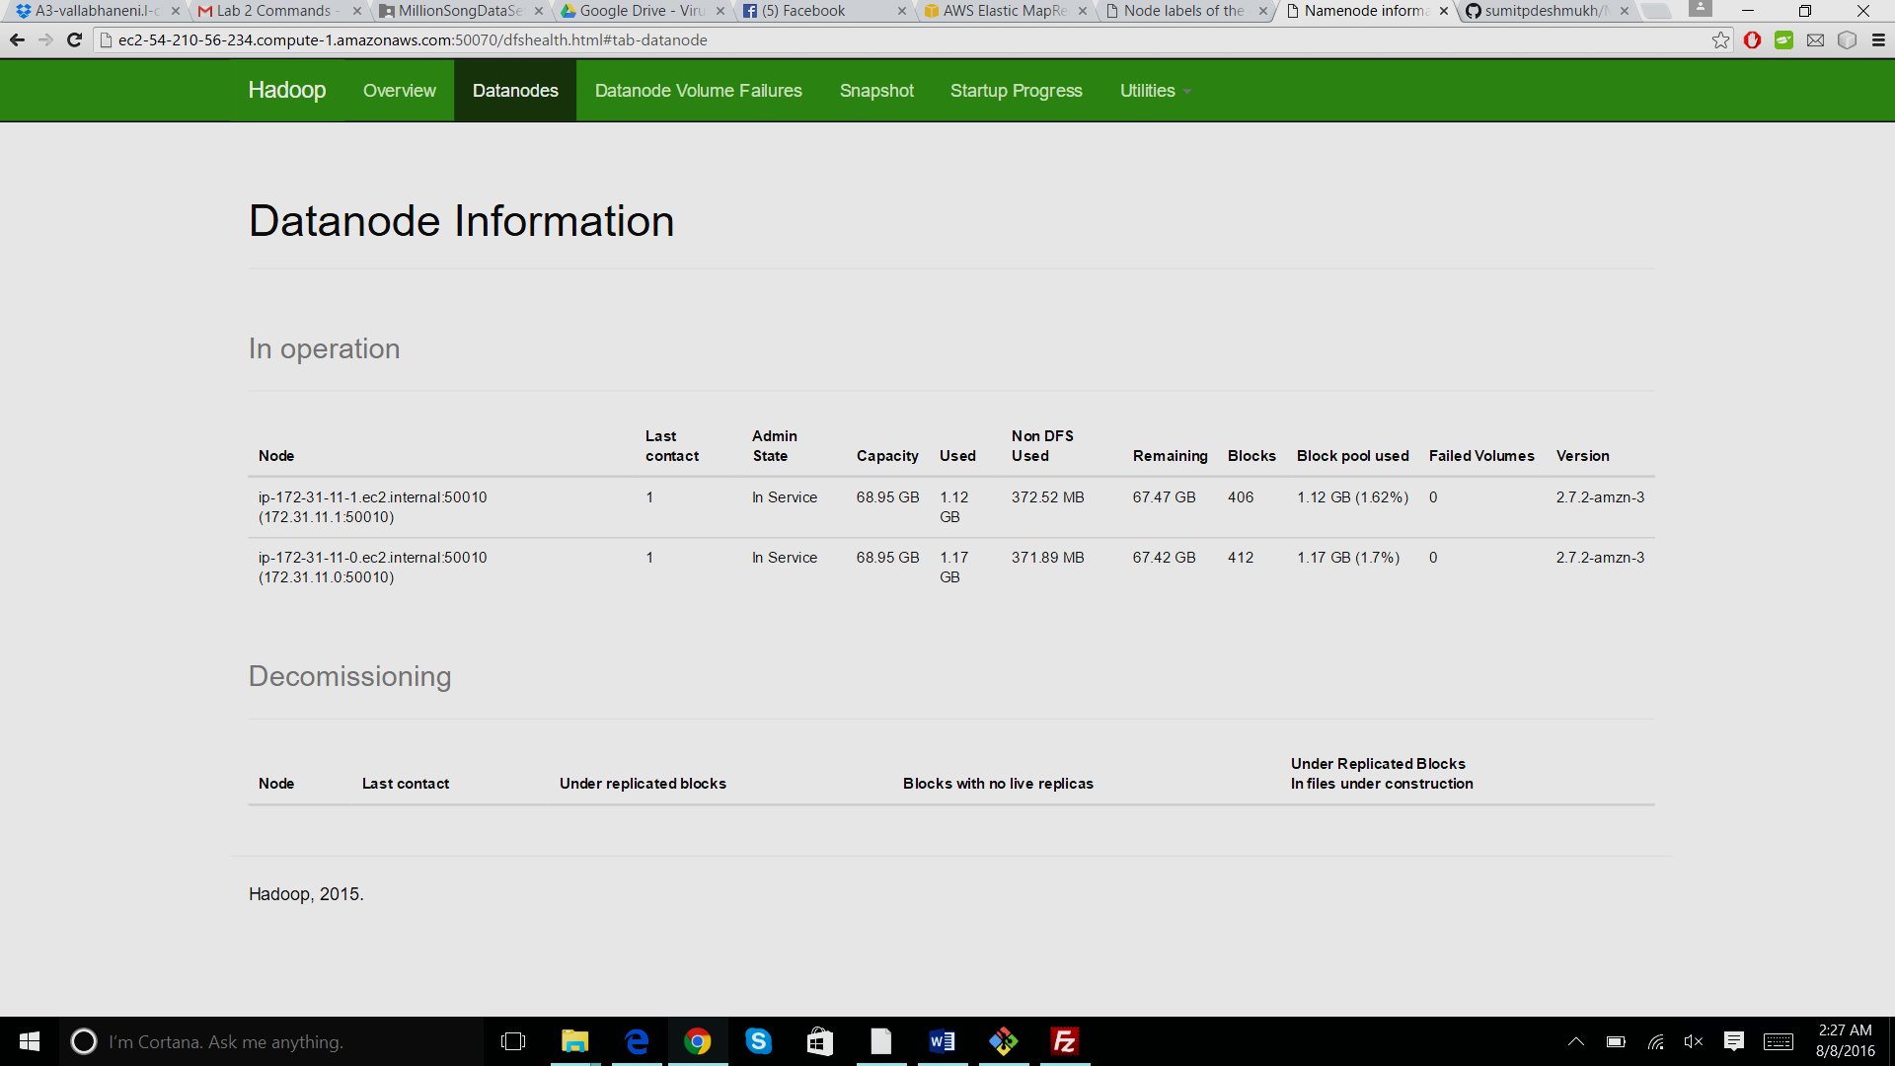

Figure 8: Two nodes crunching the Data in AWS EMR

1. **PIG**
   1. **Top 50 Most played songs**

We have used Pig 0.16.0 version to execute the commands. It calculates the top 50 songs that have highest number of views with the number of users that have viewed it, using a subset. The subset is Taste Profile Dataset which contains real user - play counts and songId, matched to the MSD.

**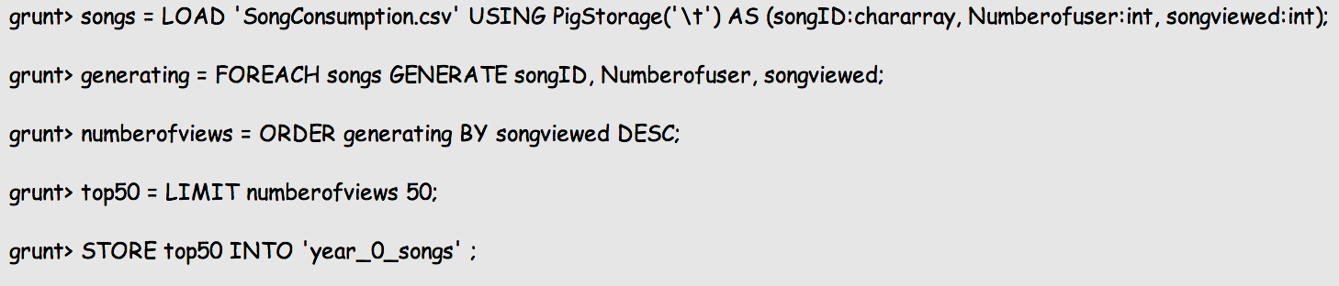**

The final output file generated contains data as below:

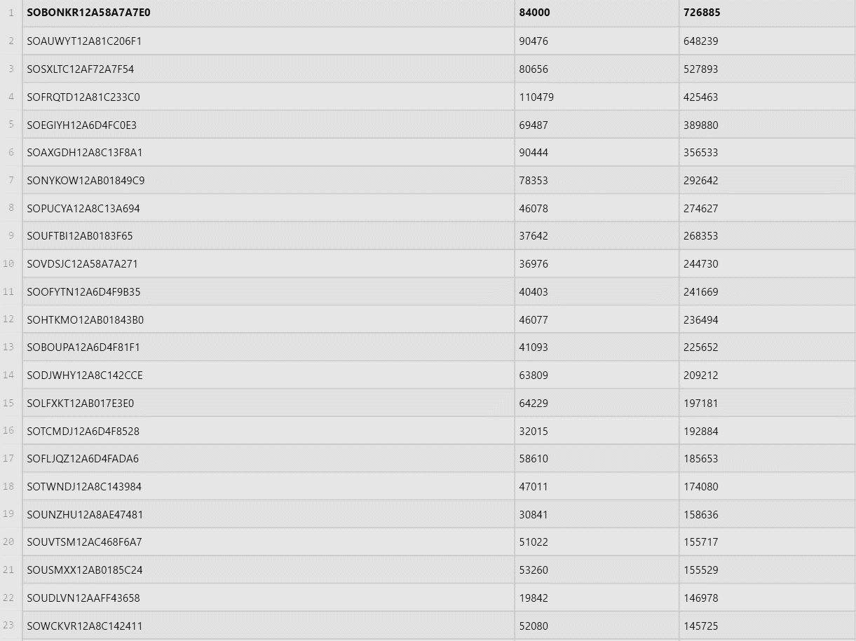

Table 5: Top 50 Most played songs

* 1. **Top 10 years with highest number of song release**

This PIG program simply calculates the top ten years in which highest number of songs have been released providing the overview of growth in song release through the years.

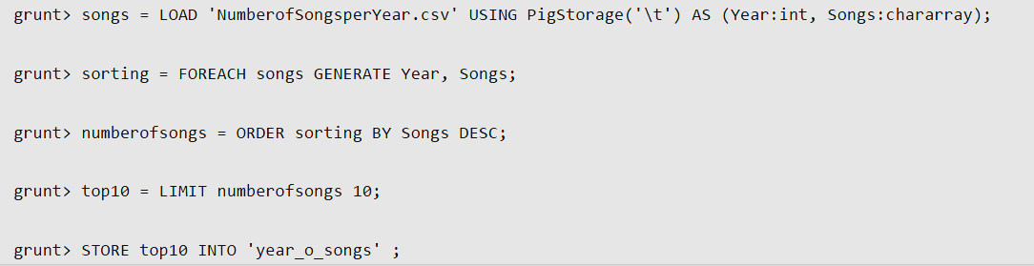

The final output file generated contains data as below:

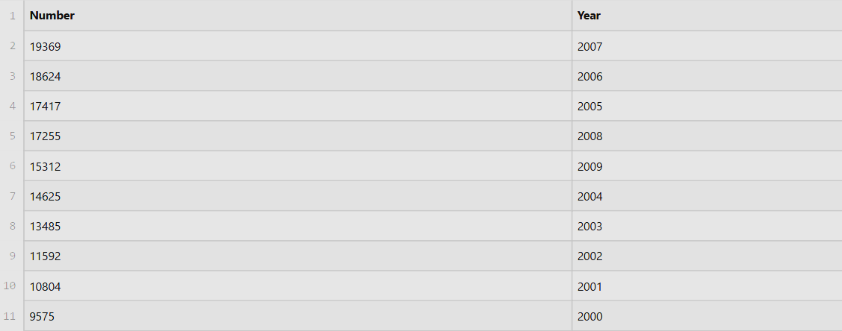

Table 6: Top 10 Years with highest number of song releases

* 1. **Top 10 years with highest number of artist debut**

This PIG program simply calculates the top ten years in which highest number of artists have been debuted providing the overview of growth in artist through the years.

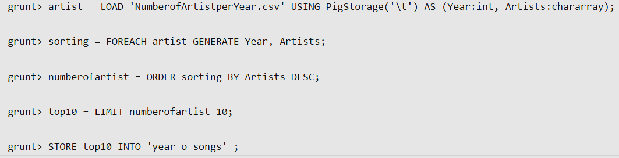

The final output file generated contains data as below:

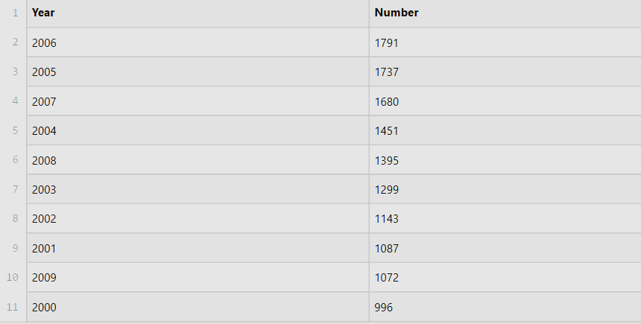

Table 7: Top 10 years with highest numbers of Artist debuted

* 1. **List of songs with Most Number of beats before 1980**

In the recent years, there are several songs with high number of beats. We were curious to know that what is the list of songs with highest number of beats before 1980. Therefore, this PIG program simply calculates the list of songs with highest number of beats before 1980. It also includes the title, artist name and loudness of that particular song.

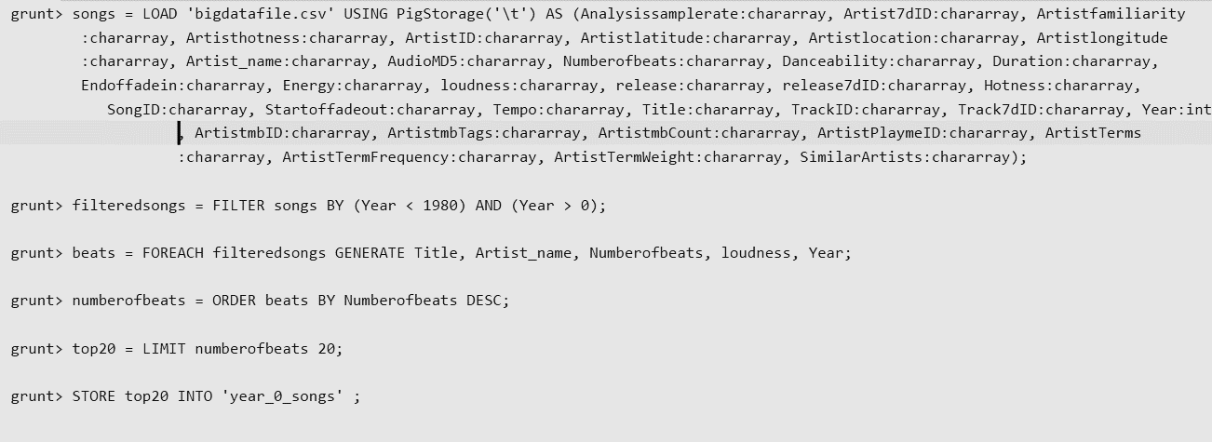

The final output file generated contains data as below:

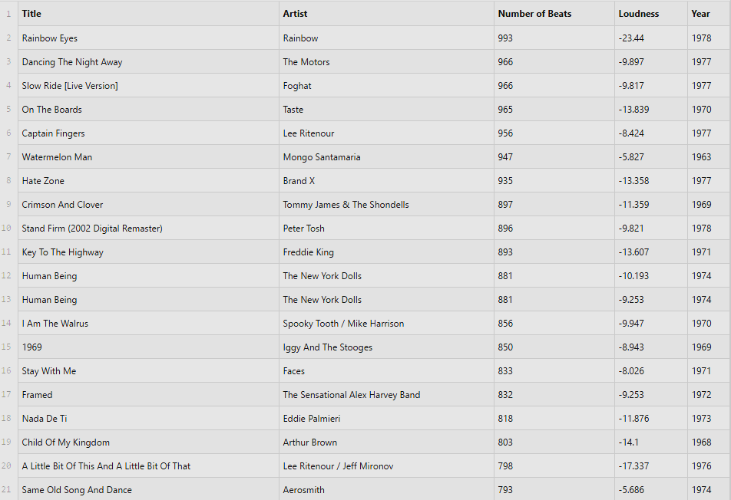

Table 8: List of songs with most number of beats before 1980

1. **Neo4J Graph Database:**

Neo4j is a highly scalable native graph database that leverages data relationships as first-class entities and provides visual representation of the data for thorough understanding of relationships between nodes.

Weused Neo4j graph database to represent relationship between a unique user and unique songs he listened to.

* 1. **A Typical view of User Node and Song Nodes**

Below is the Graph plot of a single user in this graph database. User is shown with a blue Node and songs are all red Nodes. The number of times the user has listened to a song is shown on the connecting edge.

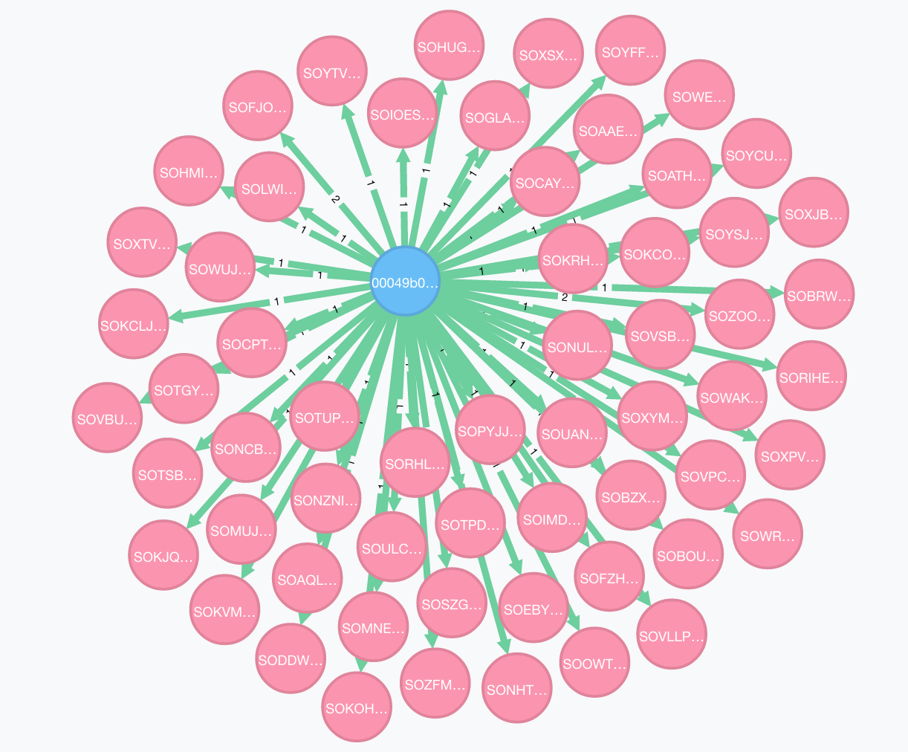

Figure 9: Used Node and Song Nodes representing relationship

* 1. **Properties of each song Node in the Neo4j Database**

Our song data had many attributes to represent each song but for simplicity we added just these 8 properties to the Neo4J database

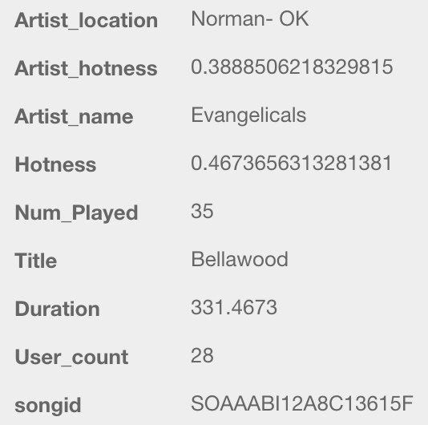

Figure 10: Properties of Song in Neo4J

* 1. **How Big the Graph Database can be?**

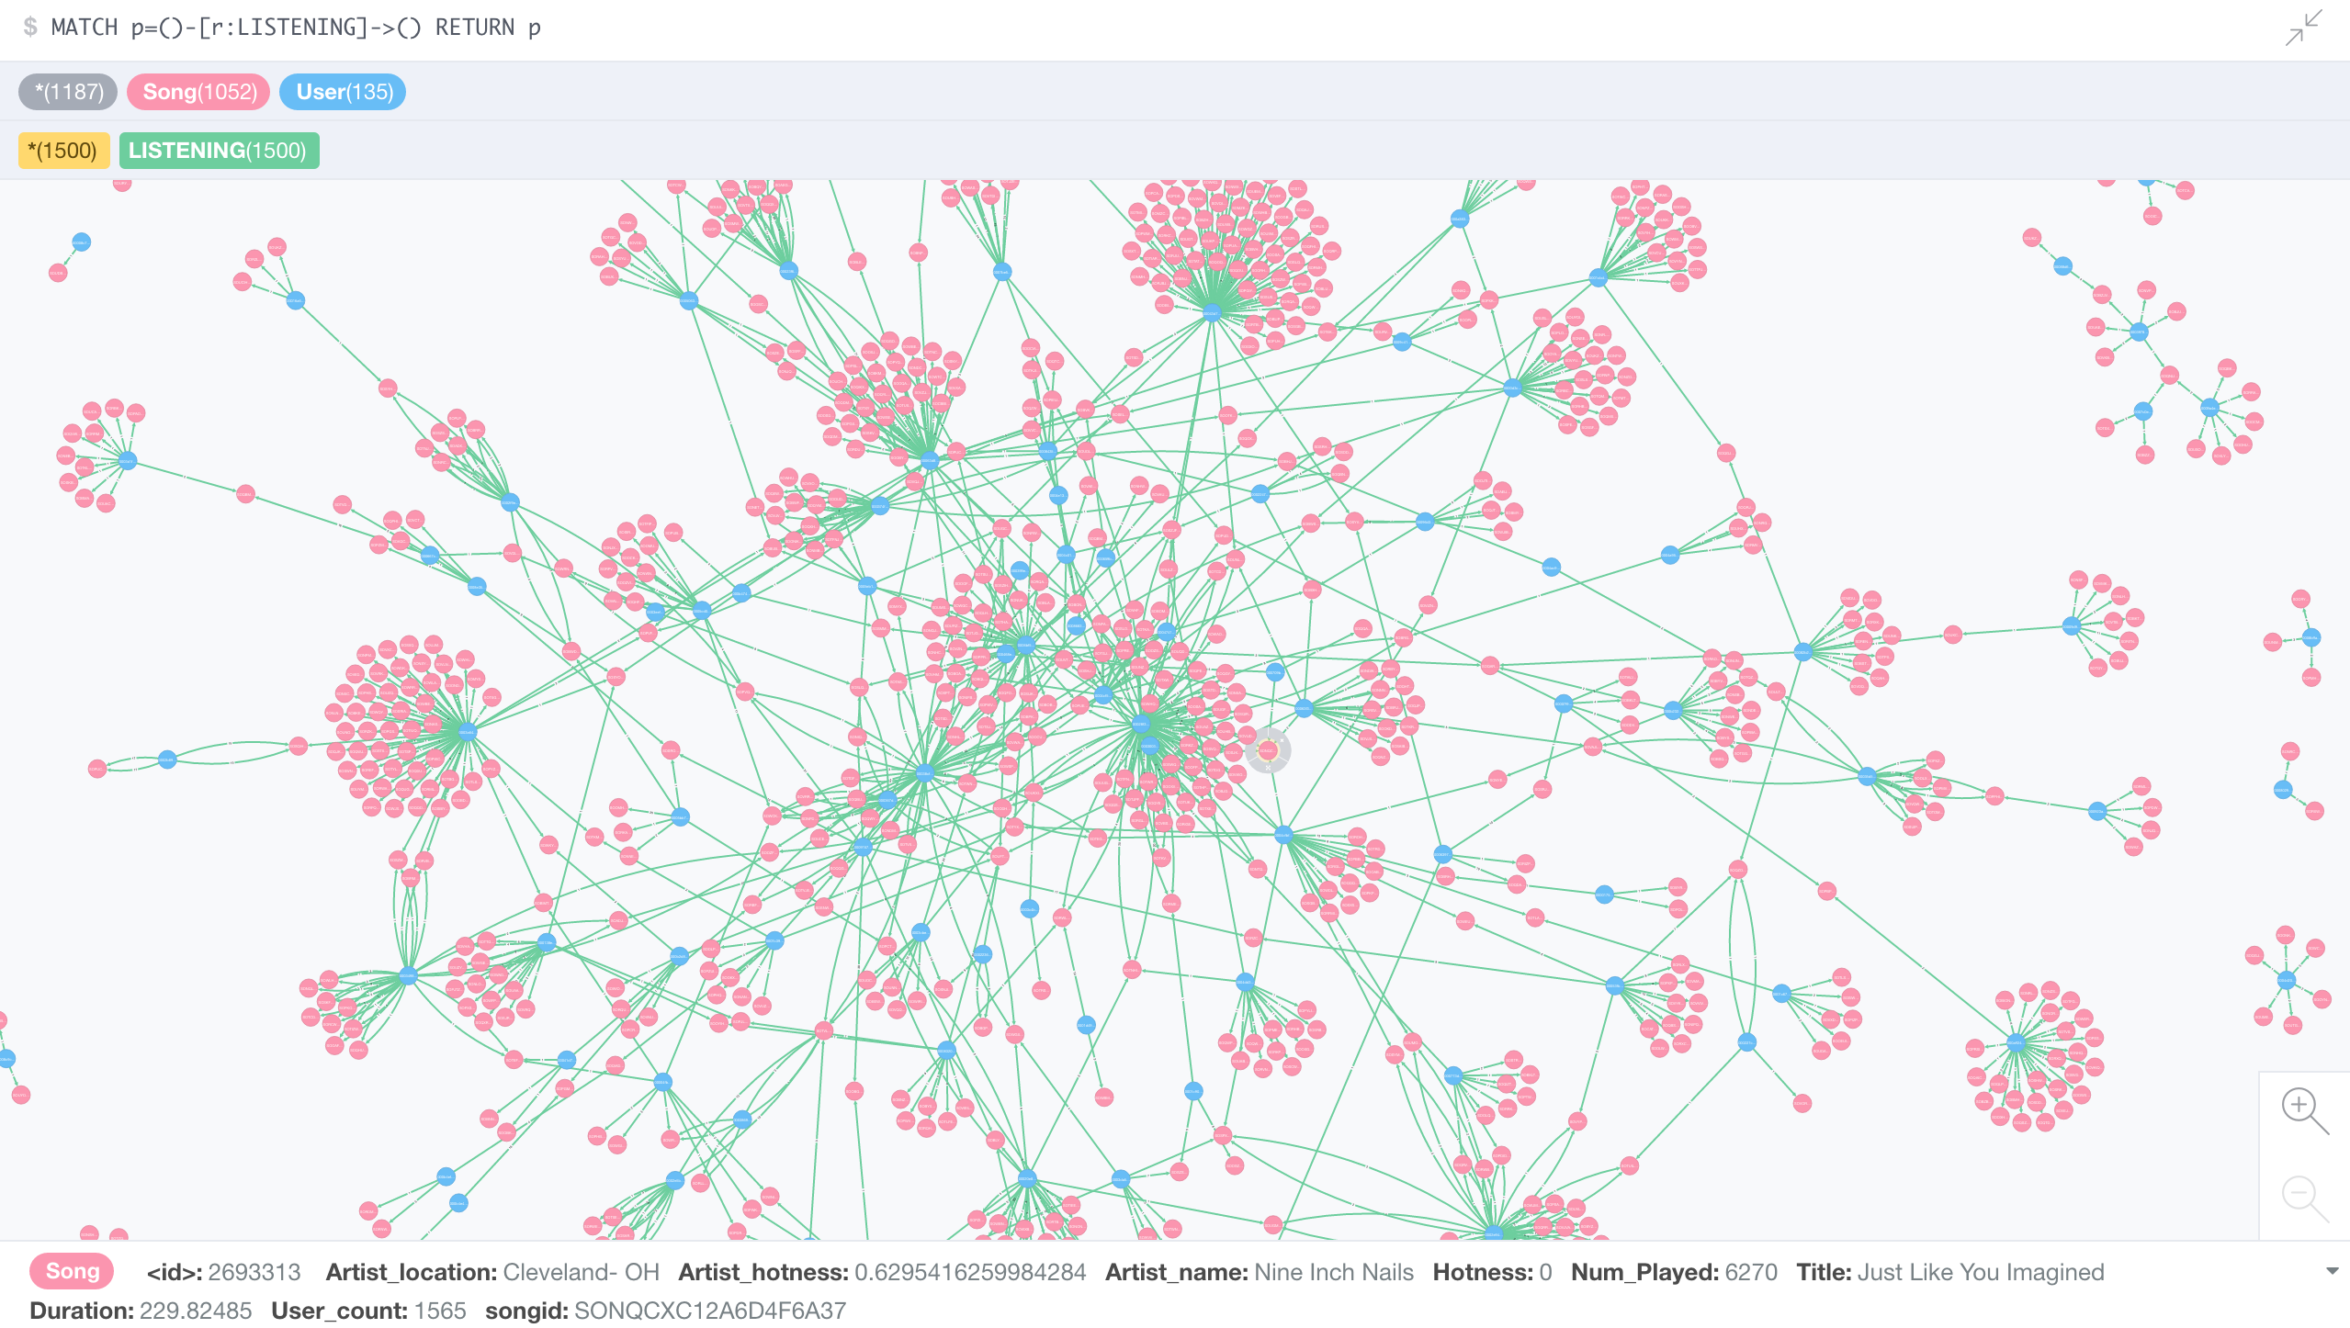

*Figure 11: Graph Representations of 1500 relationships between 1052 songs and 135 users*

* 1. **How we loaded the Neo4j Database with MSD data?**
     1. **Loading the driver**

We used Neo4j’s python driver to load the data into the database. Neo4j provides a simple bolt protocol for connection and basic authentication.



* + 1. **Loading the Neo4j DB with User Node.**

Python code snippet to add a song to the Neo4j Database.

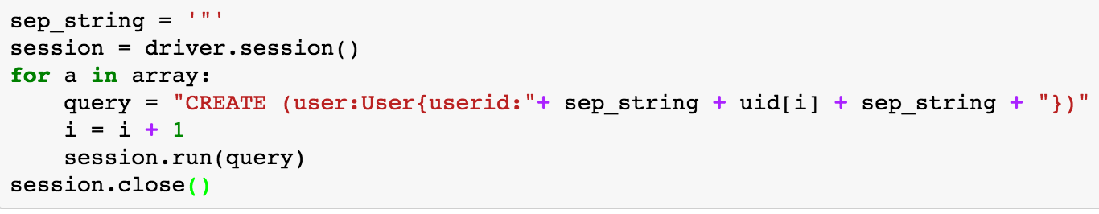

* + 1. **Loading the Neo4j DB with Song Node.**

Python code snippet to add a user to the Neo4j Database.

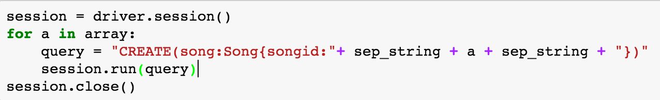

* + 1. **Loading the Neo4j DB with relationship between User node and Song node.**

Python code snippet to add the relationship between song and user to the Neo4j Database.

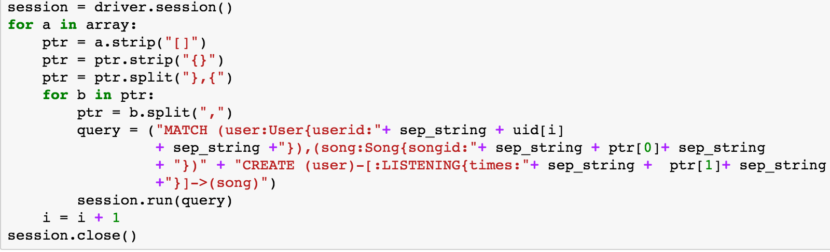

1. **Machine Learning**

We have a very rich dataset in content and features from Echo nest. They have also released a [Taste Profile dataset](http://labrosa.ee.columbia.edu/millionsong/tasteprofile). This profile dataset has 1 million users and their listening data of 1 million MSD songs. We combined this dataset with the original Million Song Dataset.

Prediction of possible audience count and Number of play count is a regression problem. First step towards achieving this is preprocessing this dataset and cleaning the data.

* 1. **Data Preparation**

The data is more or less preprocessed in the MR jobs already but we ensured its cleanliness by cleaning the missing data and removing duplicate rows.

Azure ML Studio picked few numeric features as string so we had to convert them to numeric features by using Edit Metadata block.

Some other preprocessing techniques that we tried are

1. Removing all nan values.
2. Converting the “Year” attribute into categorical that would map each year to that decade.
3. e.g. All years from 1971 to 1980 are converted to 1980. This converted all years from 1922 to 2010 to their respective decades and resulted in 9 unique categories.
4. Artist has Music Brainz tags like pop, rock and indie etc. We found out the most common tags for all the artist and mapped these tags to only 12 categories. So we have 11 unique categories and all others are mapped as a single category “Others”.
5. Removed all columns such as (PlaymeID, 7dID, MB tag count etc.) that are less of importance with respect to Target variable. (#Audience and #PlayCount)

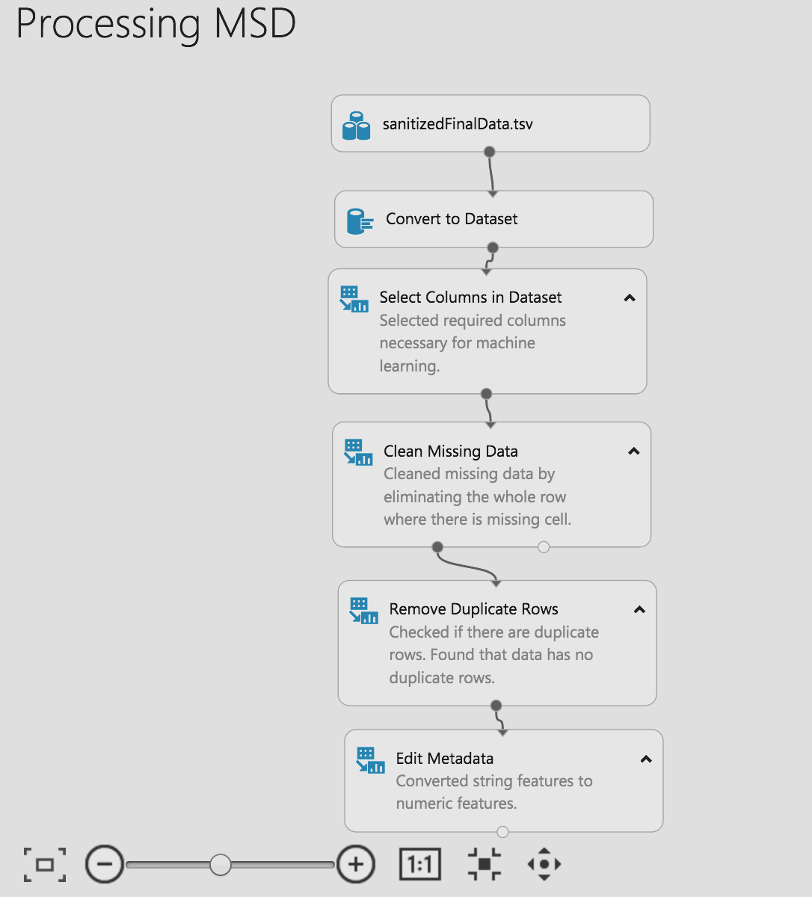

*Figure 12: Data Preparation*

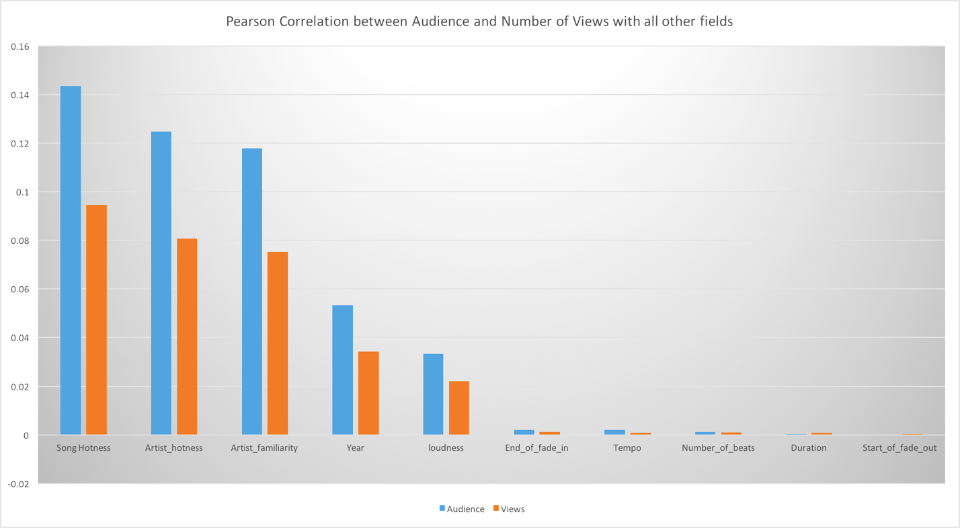

*Figure 13: Pearson Correlation Coefficient with respect to Targets*

1. Pearson Correlation Coefficient is calculated between Target variables and all other independent attributes of the MSD dataset. This graph shows that “Song Hotness” is positively correlated with Audience and Views. This gives good indication of number of columns that will go as input in Regression Model.
   1. **Linear Regression Model**
2. We used Bayesian Liner Regression to solve this linear regression problem. In statistics, the *Bayesian* approach uses prior information about the parameters to propose with a likelihood function to generate estimates for the parameters.
3. We split the dataset in 80:20 proportion between training and test set. By not having the cross validation set in this approach our estimates were not as accurate as cross validation set. So we tried cross validation test to build a better model.
4. The bias in training with a fixed set is eliminated by using Cross Validation module. We used two separate modules to evaluate the results for each of the target variable.

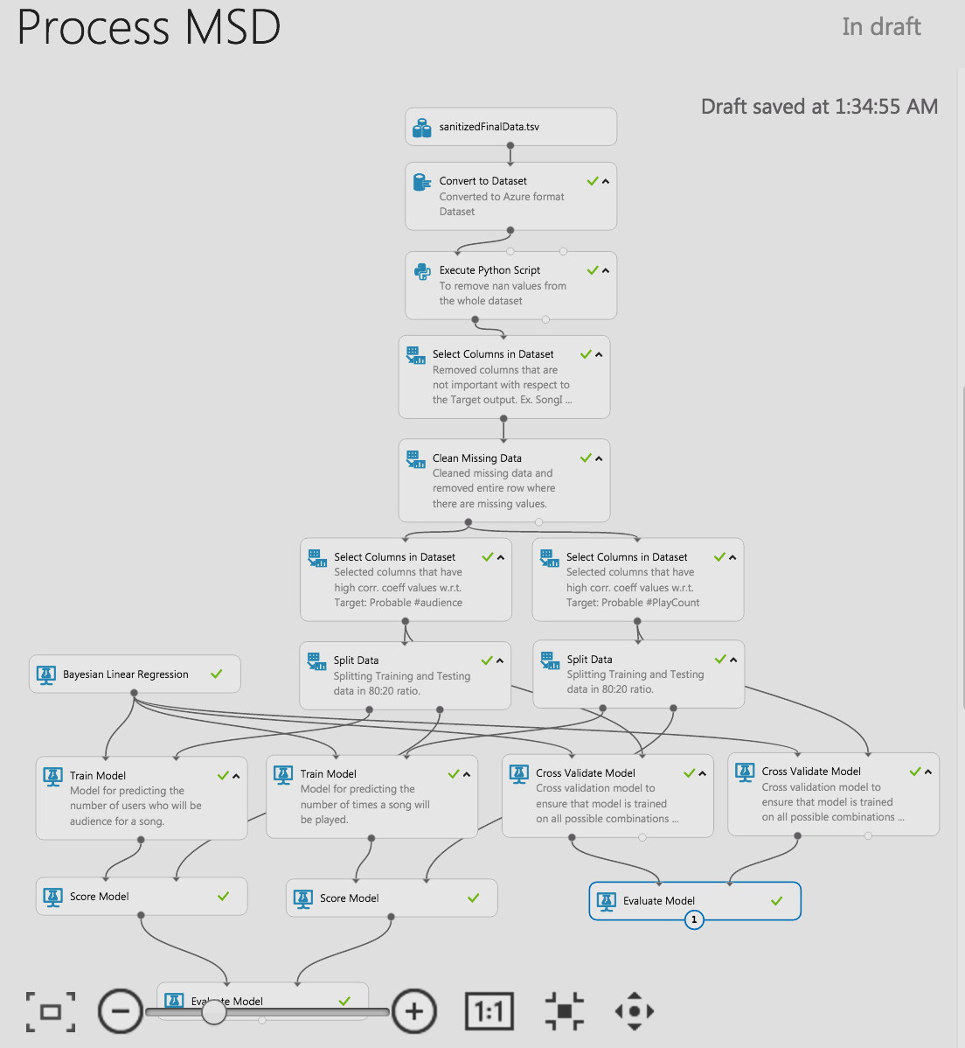

*Figure 14: Bayesian Linear Regression Model*

* 1. **Standard Performance Parameters:**

Target Variable

#Audience

#Views

*F*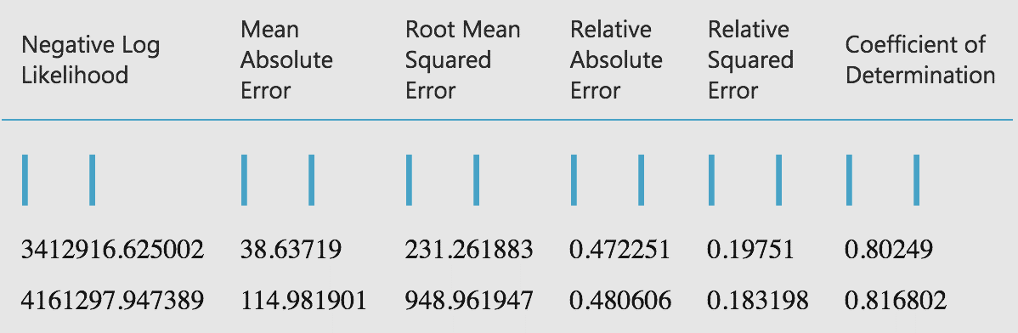*igure 15: The standard performance parameters to evaluate the model*

1. **Challenges in Processing MSD:**
2. Huge data to crunch (approximately 280 GB).
3. Extracting data into CSV from HDF5. We were unable to make this conversion in parallel on EMR.
4. Data Cleaning and preprocessing due to missing/junk values for certain fields.
5. Limited usage workspace on Microsoft Azure ML Studio (only 10 GB free space).
6. Building the architecture in Neo4j with 2 nodes and adding a relationship.
7. **Conclusion:**

After Processing MSD we could provide answers to questions like Most Dense songs, Most played songs in the dataset. We now know how duration, number of beats in a song have evolved over the years. We could establish relationship between users and the songs they listened to through Graph Database like Neo4j. It showed us the dense relationships between the songs which are listened more number of times. Pig and Neo4j both allowed us to query the datasets and retrieve information that answered daunting questions.

We could create a Model of Linear regression to predict the probable audience and number of views a particular song can have. The azure machine learning studio blocks coherently explained the whole regression procedure. At last, we had fun understanding and playing with Million Song Dataset.

1. **Citation:**
2. Thierry Bertin-Mahieux, Daniel P.W. Ellis, Brian Whitman, and Paul Lamere. The Million Song Dataset. In Proceedings of the 12th International Society for Music Information Retrieval Conference (ISMIR 2011), 2011.
3. http://labrosa.ee.columbia.edu/millionsong[/](http://labrosa.ee.columbia.edu/millionsong/" \t "_blank)
4. <https://aws.amazon.com/datasets/million-song-dataset/>
5. <http://ismir2011.ismir.net/papers/OS6-1.pdf>
6. <http://blog.echonest.com/post/3639160982/million-song-dataset>
7. https://neo4j.com/docs/developer-manual/current/drivers/#[driver-introduction](https://neo4j.com/docs/developer-manual/current/drivers/)
8. <https://hadoop.apache.org/docs/r1.2.1/mapred_tutorial.html>
9. <http://www.tutorialspoint.com/apache_pig/index.htm>

1. Derived Attribute [↑](#footnote-ref-2)